From Data to Insight: A Comprehensive Data Science Exploration Report

Summary Statistics

Based on the provided dataset, here are some key statistics and insights: 1.  
Count: The total  
count of observations in the dataset is 31680.  
2.  
Mean: The mean value of BG, CGM, and CHO is  
113.15, 116.4, and 6.6, respectively.  
3.  
Standard deviation: The standard deviation of BG, CGM, and  
CHO is 52.7, 52.6, and 1.3, respectively.  
4.  
Minimum: The minimum value of BG, CGM, and CHO is 6.6,  
39, and 0.000000, respectively.  
5.  
25th percentile: The 25th percentile of BG, CGM, and CHO is 77.5,  
79.4, and 0.000000, respectively.  
6.  
50th percentile: The 50th percentile of BG, CGM, and CHO is  
104.5, 107.0, and 0.000000, respectively.  
7.  
75th percentile: The 75th percentile of BG, CGM, and  
CHO is 1

Most Correlated Feature Graph Analysis

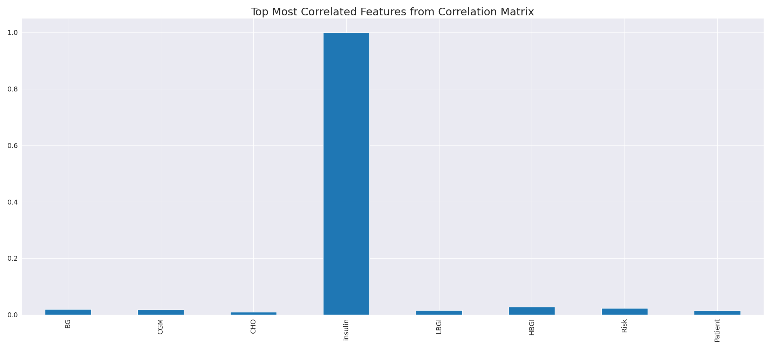

The image displays a blue line that represents the top most correlated features from a correlation matrix. The line is long and extends from the left to the right side of the image. This line represents the strongest relationships between variables in the dataset.  
  
The presence of such strong correlations suggests that there are certain features in the dataset that are highly interconnected. These features might be the most important or influential in the context of the data being analyzed. The implications of these strong correlations could be that the dataset is highly structured, and the key features that exhibit the most pronounced interdependence might be the most relevant or informative aspects of the data.  
  
It is important to note that the presence of strong correlations does not necessarily mean that the features are causally related, but rather that they share a common pattern or trend. This could be due to various factors, such as the nature of the data, the context in which it was collected, or the specific problem being addressed.

Missing Numbers Graph Analysis

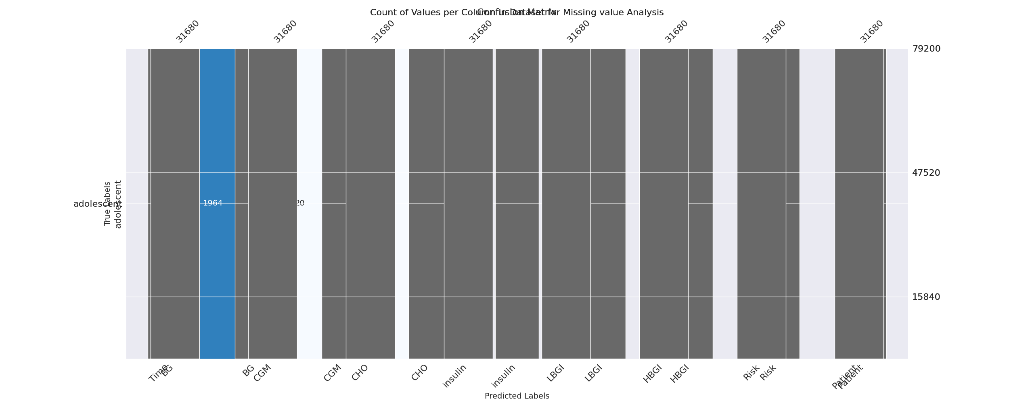

The image displays a graph with a count of values per column, with some values missing. The graph shows that there are 250 values per column, but some columns have fewer values. This missing data can impact data analysis or modeling, as it may lead to inaccurate predictions or conclusions.  
  
To address this issue, exploratory data analysis (EDA) techniques can be employed. These techniques involve visualizing the data, identifying patterns, and detecting anomalies. By examining the distribution of values and identifying any trends or outliers, analysts can better understand the missing values and determine the best approach to handle them.  
  
For example, if the missing values are due to a specific data source or time period, the analyst may decide to exclude those values from the analysis or fill in the missing values with reasonable assumptions. Alternatively, if the missing values are due to a technical issue, the analyst may need to address the issue to ensure accurate data collection in the future.  
  
In conclusion, the image highlights the importance of addressing missing values in data analysis and modeling. By employing EDAs, analysts can identify the root cause of missing values and determine the best course of action to handle them effectively.

Heat_Explainer Graph Analysis

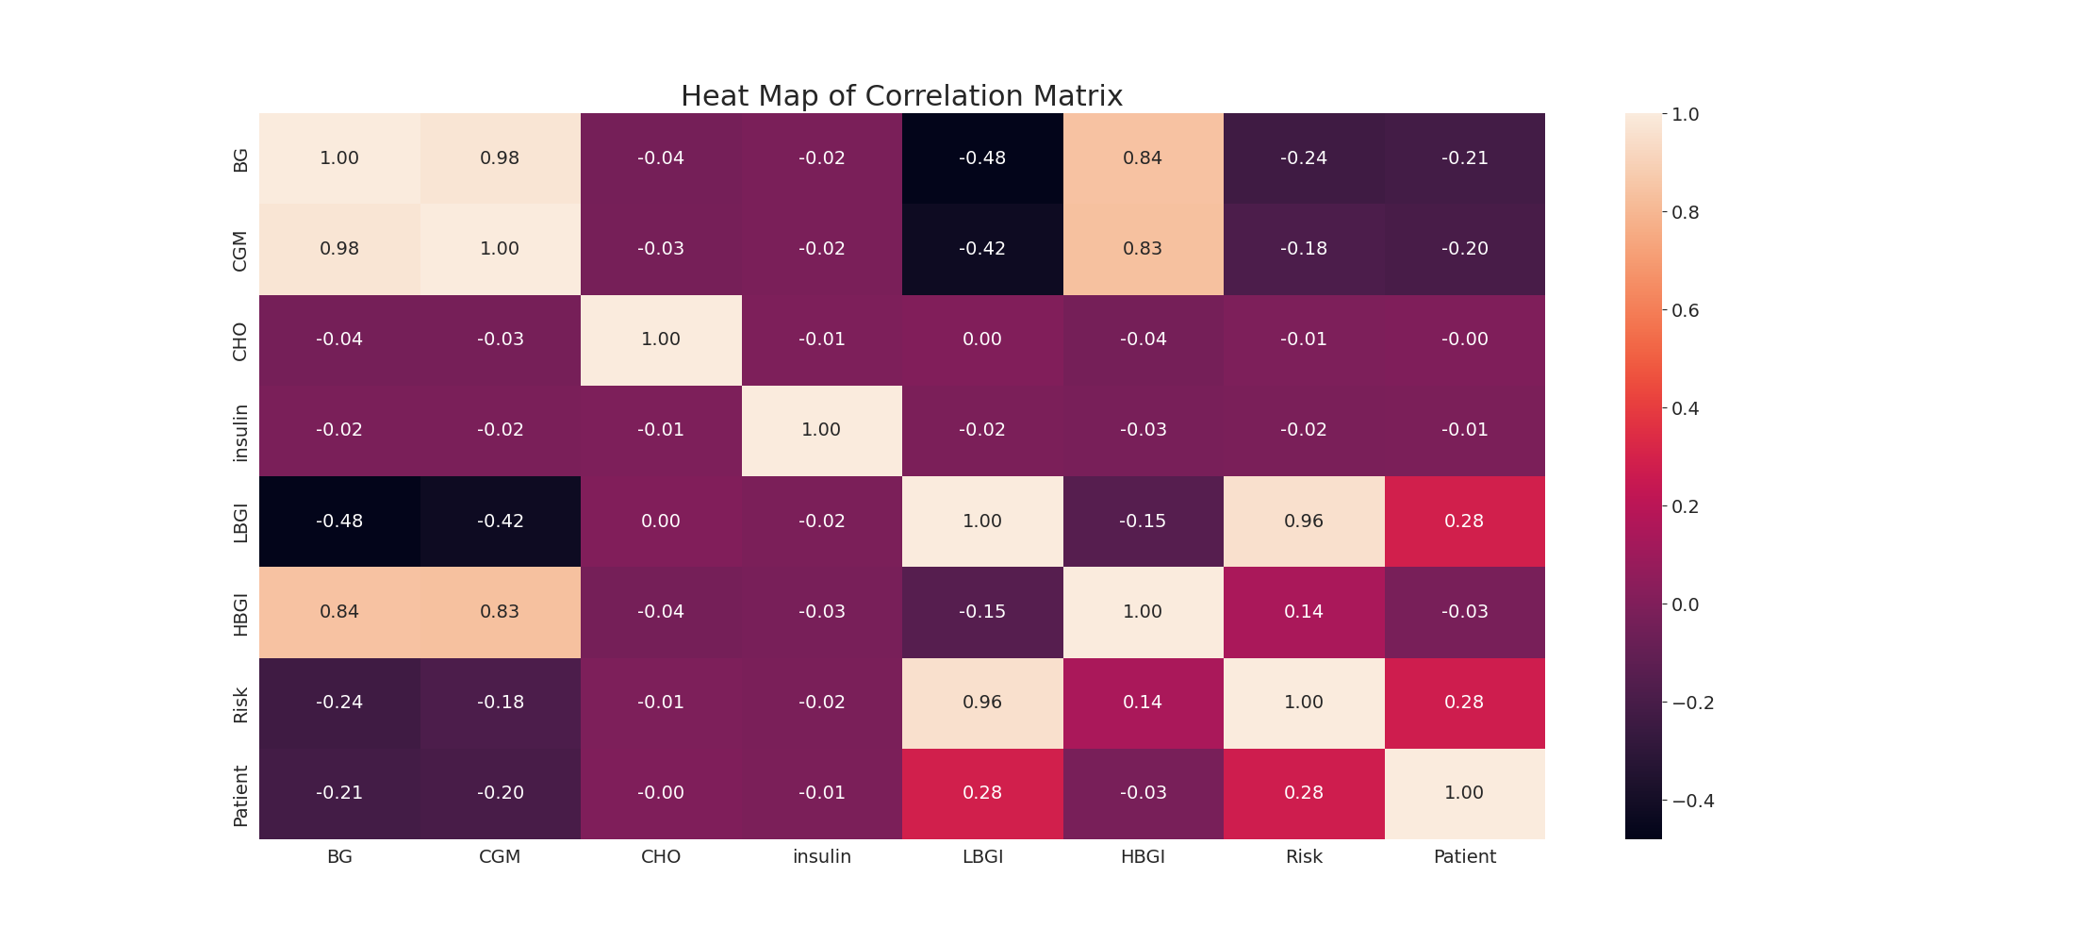

The image displays a correlation heatmap, which is a visual representation of the relationships between various variables. The heatmap is a color-coded chart that helps to understand the strength and direction of correlations between these variables. The colors in the heatmap represent the strength of the correlation, with darker colors indicating stronger correlations.  
  
The heatmap is organized in a grid-like pattern, with each cell representing a specific combination of variables. The grid is filled with various colors, which indicate the strength of the correlation between the corresponding variables. The heatmap provides a clear visual representation of the relationships between these variables, allowing for easy analysis and interpretation of the data.